Rolando Ortega Arocho SDEV-435-81

The Link Social Media

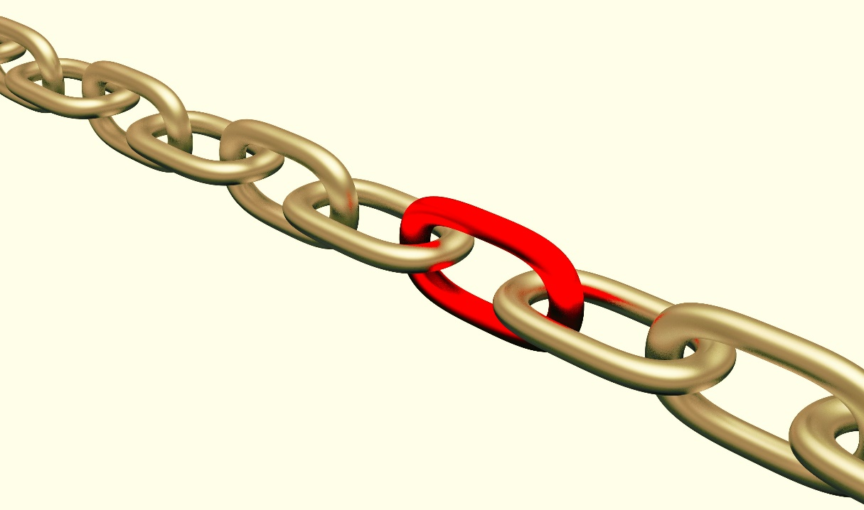

**Main page**

Including business description, and contact information

Map and Directions

Places to Go

With Reviews

Video Chat

Live post and Streaming

Photo Gallery

# Background

For this assignment I choose to ceated a a social media web application. The internet changed the way people interact with each other as well as work culture, and those changes first arose on social media sites. That is why social networks for apps are so important.

Social media helps people establish better relationships with their family and friends, and now the networking sites also show their significance for apps.

That is why people spend a lot of their time online browsing social sites, and usage has only gone up with increase in the use of smartphones and tablets in

Mobile devices are gaining more and more space amongst people when compared to other ways of internet access. It is because prices and plans have become increasingly affordable and accessible.

Mobile accessibility in turn lures people to always stay online thus encouraging more time spent on social media. My objectives are going to be:

* Create a social network where the user can meet people.
* A webpage where the user can be in touch with family and friends.
* A page where people can join groups to comment, share information and opinion.
* The option to share pictures and videos.
* Information about places with reviews.

As well my Target audience are:

* Males and Females 20+
* Live in Texas U.S
* Meet cultures and diversities
* Using different types of operation systems
* Easy to use for all level of computer knowledge

The style or site type is:

* Billboard (A site providing important information for especial interest groups and nonprofit organizations and providing multiple levels of information with page templates, extracting information from data-bases.

The budget is in process and it will be update when its finalized and the web application is fully completed.

# Database or Data Store Design

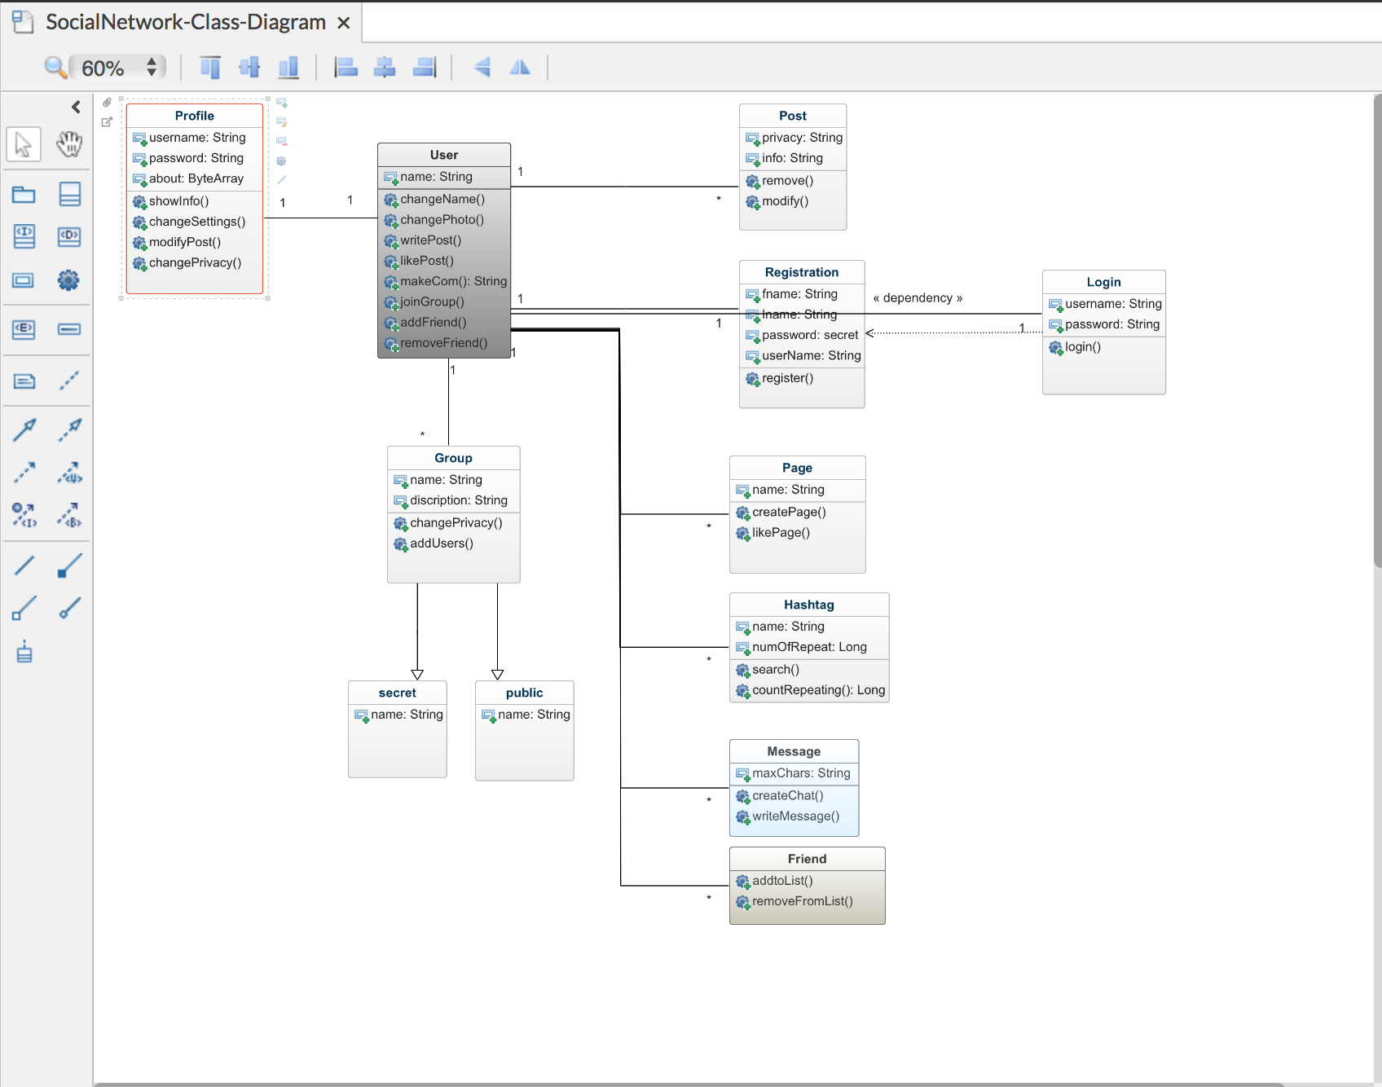

Copy of my preliminary UML design for the social media web The Link. For this I will using UMLDesigner for Mac in combination of MySQL, HTML and CSS for color and font for the page.

# Screen Mockups

|  |  |  |  |  |  |  |  |
| --- | --- | --- | --- | --- | --- | --- | --- |
| **The Link**   |  |  | | --- | --- | |  | /Users/rolandoortega/Desktop/Screen Shot 2018-09-30 at 3.39.45 PM.png | |  | Reviews, gps acces and picture of diferent places will be offered on this section. | |  |  |   /Users/rolandoortega/Desktop/Screen Shot 2018-09-30 at 3.41.25 PM.png  Weather and places to go with description can find here. The weather will be obtain from different finders such google. |  |

# Report Mockups

|  |  |  |  |  |  |  |  |  |  |  |  |  |  |  |  |  |  |  |  |  |  |  |  |  |  |  |  |  |  |  |  |  |  |  |  |  |  |  |  |  |  |  |  |  |  |  |  |  |  |  |  |  |  |  |  |  |  |  |  |  |  |  |  |  |  |  |  |  |  |  |  |  |  |  |  |  |  |  |  |  |  |  |  |  |  |  |  |  |  |  |  |  |  |  |  |  |  |  |  |  |  |  |  |  |  |  |  |  |  |  |  |  |  |  |  |  |  |  |  |  |  |  |  |  |  |  |  |  |  |  |  |  |  |  |  |  |  |  |  |  |  |  |  |  |  |  |  |  |  |  |  |  |  |  |  |  |  |  |  |  |  |  |  |  |  |  |  |  |  |  |  |  |  |  |  |  |
| --- | --- | --- | --- | --- | --- | --- | --- | --- | --- | --- | --- | --- | --- | --- | --- | --- | --- | --- | --- | --- | --- | --- | --- | --- | --- | --- | --- | --- | --- | --- | --- | --- | --- | --- | --- | --- | --- | --- | --- | --- | --- | --- | --- | --- | --- | --- | --- | --- | --- | --- | --- | --- | --- | --- | --- | --- | --- | --- | --- | --- | --- | --- | --- | --- | --- | --- | --- | --- | --- | --- | --- | --- | --- | --- | --- | --- | --- | --- | --- | --- | --- | --- | --- | --- | --- | --- | --- | --- | --- | --- | --- | --- | --- | --- | --- | --- | --- | --- | --- | --- | --- | --- | --- | --- | --- | --- | --- | --- | --- | --- | --- | --- | --- | --- | --- | --- | --- | --- | --- | --- | --- | --- | --- | --- | --- | --- | --- | --- | --- | --- | --- | --- | --- | --- | --- | --- | --- | --- | --- | --- | --- | --- | --- | --- | --- | --- | --- | --- | --- | --- | --- | --- | --- | --- | --- | --- | --- | --- | --- | --- | --- | --- | --- | --- | --- | --- | --- | --- | --- | --- | --- | --- | --- | --- | --- | --- |
|  | **Design Report**   |  |  |  |  |  |  |  |  | | --- | --- | --- | --- | --- | --- | --- | --- | | The Link social media |  |  |  |  |  |  |  | | **Mockup Report** | | | | | |  |  | | **The Link** | | | | | |  |  | | Period of programing and design time | | | | | |  |  | |  |  |  |  |  |  |  |  | | **Hours** | **1** | **2** | **3** | **4** | **5** |  |  | | |  | | --- | | Monday | |  |  |  |  |  |  |  | | |  | | --- | | Tuesday | |  |  |  |  |  |  |  | | |  | | --- | | Wednesday | |  |  |  |  |  |  |  | | |  | | --- | | Thursday | |  |  |  |  |  |  |  | | Friday |  |  |  |  |  |  |  | | |  | | --- | | Saturday | |  |  |  |  |  |  |  | | |  | | --- | | Sunday | |  |  |  |  |  |  |  | |  |  |  |  |  |  |  |  | |  |  |  |  |  |  |  |  | |  |  |  |  |  |  |  |  | | Time average spent in the design and programing including Mockup and WBS of The link social media every week.   |  | | --- | |  | |  |  |  |  |  |  |  | |  |  |  |  |  |  |  |  | |  |  |  |  |  |  |  |  | |  |  |  |  |  |  |  |  | |  |  |  |  |  |  |  |  | |

# Maintenance Features

The user will be able to update their posting, what our friends are doing, we also want to let them know what we are up to, how we feel today, and what we think about something. Options similar to existent social medias like Facebook and twitter.

The implementation of real text in text-based content was done. Example: in frequently questions and contact I added contact real information like address, phones and questions about my web story board. Subject can do this by clicking the logo or searching in the we browser at the top of the first page.

The subject will be able or enable a GPS locator to get access and routes to different destinations.

Access to this social web will be granted in the first page, under created an account if the person has already an account and does not remember his password or user name can request his or her user account by clicking forgot password or username.

Access to live video streaming will be granted automatic after user goes to the second page. From photo gallery subject can select any picture to be used as a profile picture.

Weather will be in constant change due to variation of the days.

Monitoring of the link will be done periodically because links become broken over time. With changes within the site and if you referenced someone in one of your articles or somewhere else within the site links could have changed or are broken.

Possibility to use Site up because is a small program that runs on your computer in the background checking your site on a regular basis. It will notify you when the site is down with a popup. Obviously though, your computer has to be on for it work.

# Work Breakdown Structure (WBS)

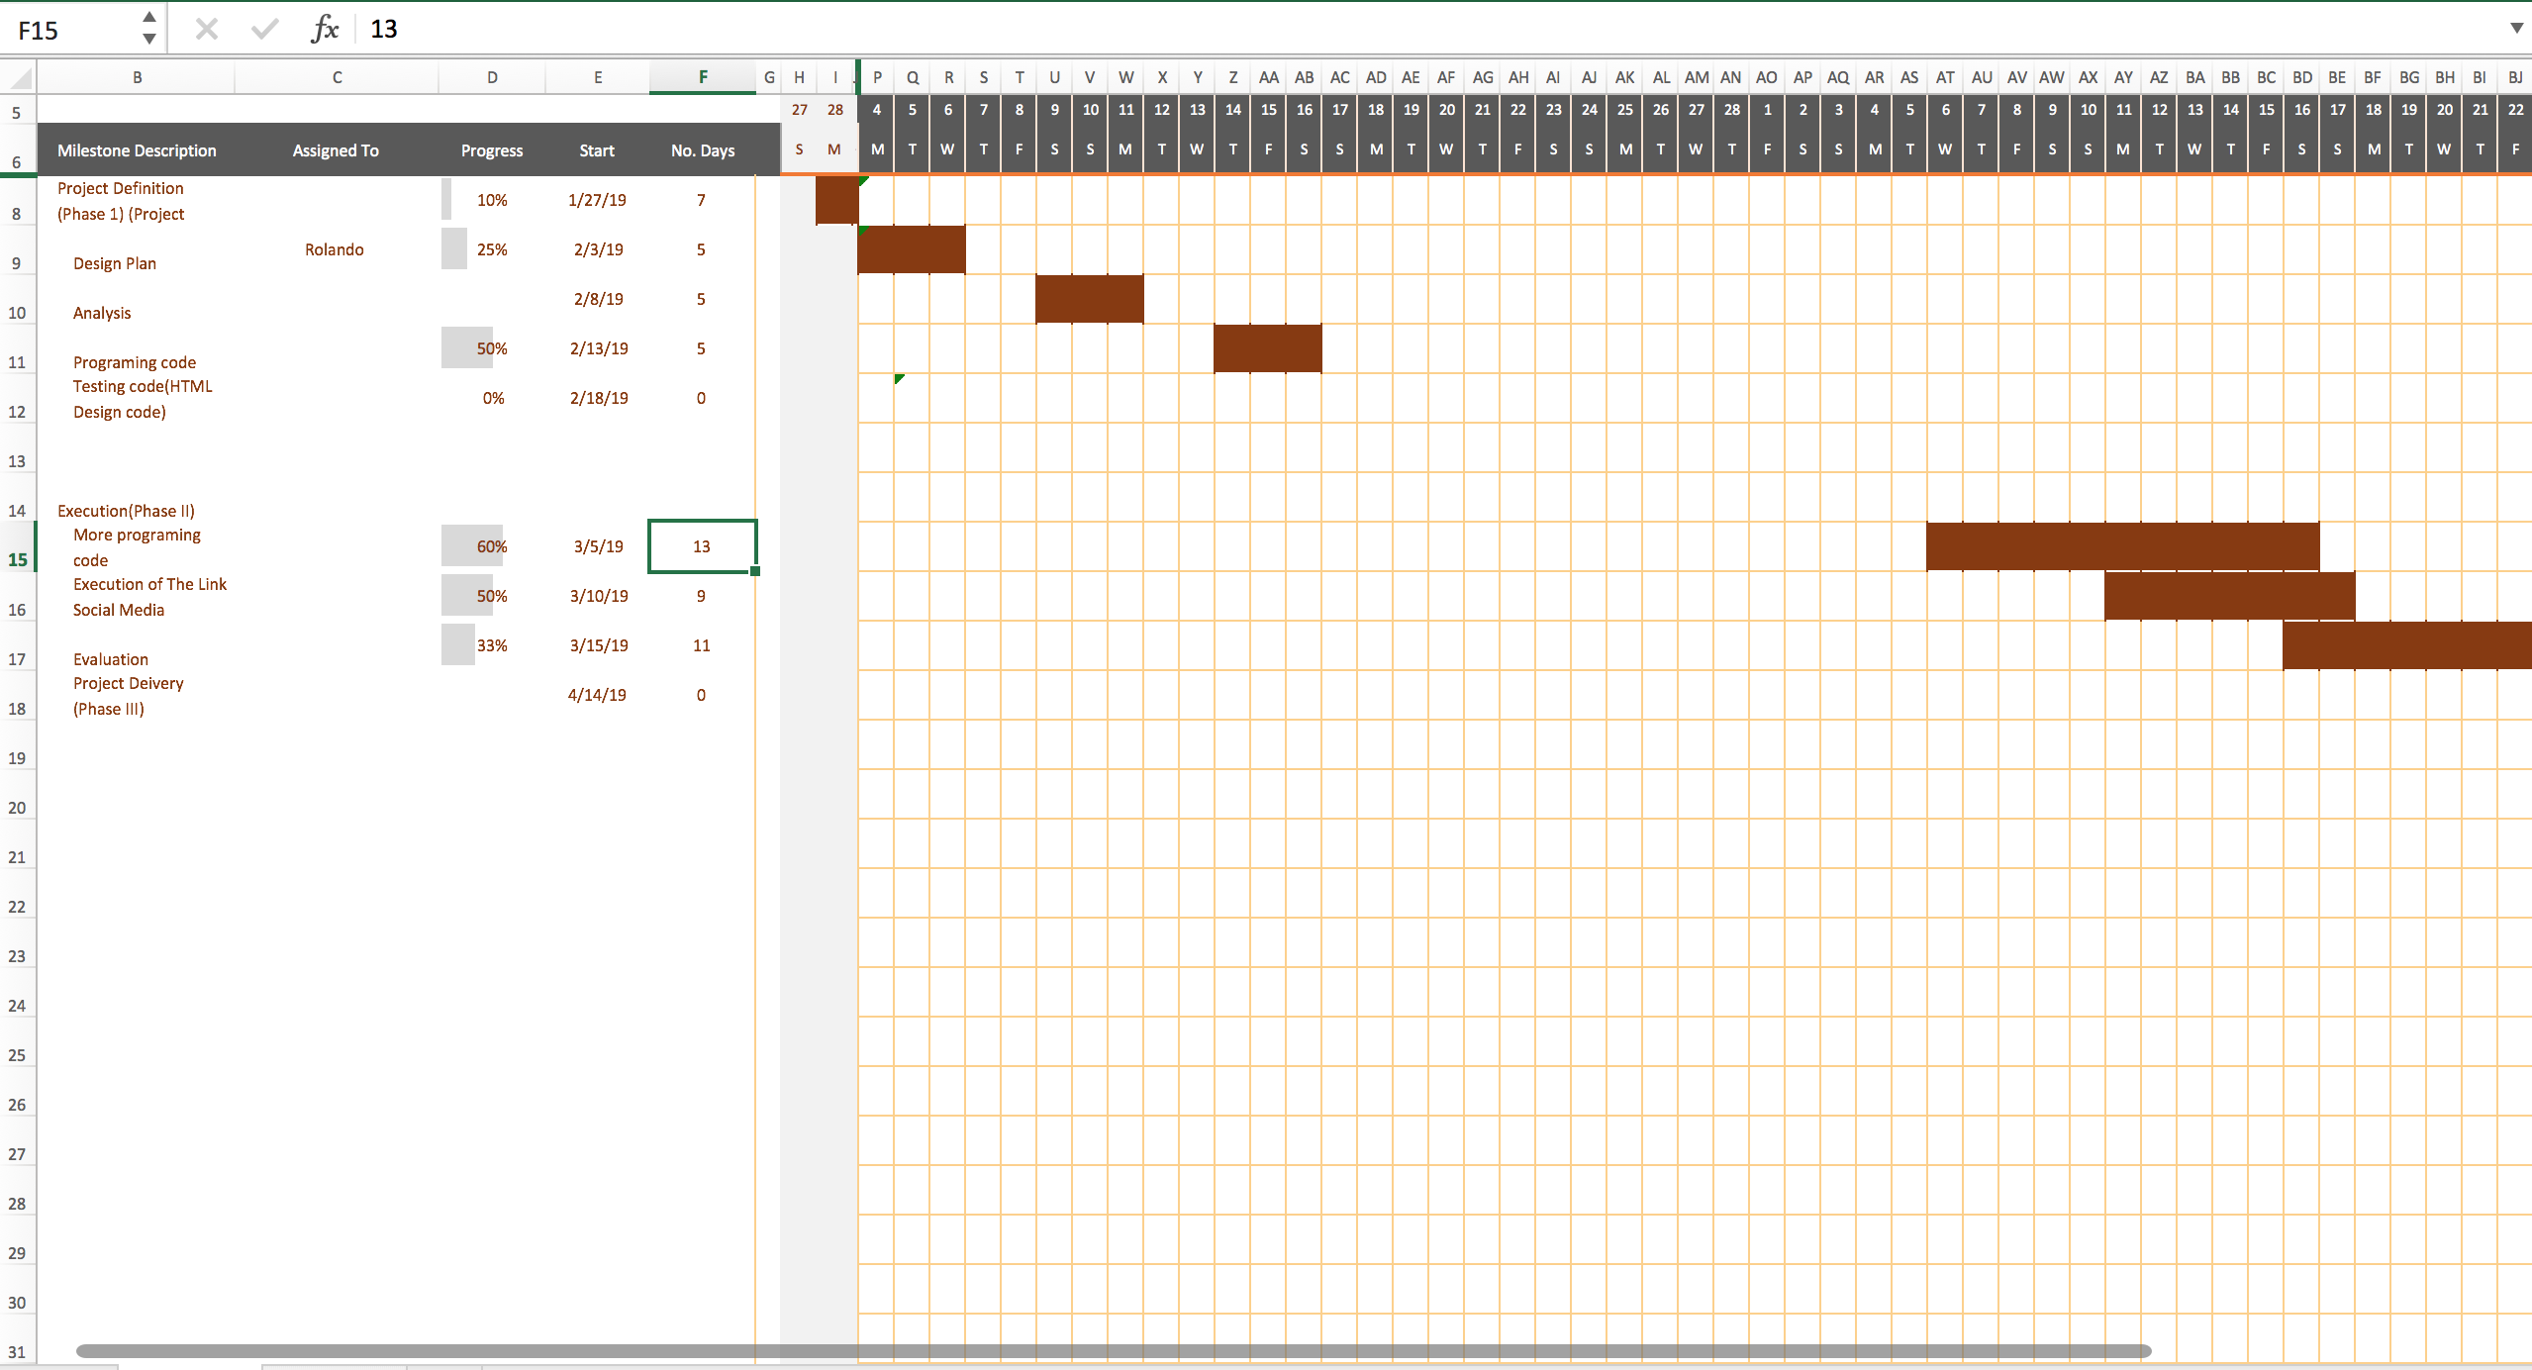

# Summary

I redesign the project in a way to obtain the best user experience and easy to follow. The addition of multiple pages following the rules of wire framing will be included. I include one page for user action and its results in another page. The colors and graphics were eliminated, because the color distracts from the information architecture, interaction design, and content. This will be done later on to improve the design. The addition of header, footer, navigation, content area all organized in a way that makes it usable were done. This is important to have for a better and easy structure to follow. This has or will been included it for each page so it doesn't interfere with the layout and then use an arrow to point from the annotation to where the key action is. The implementation of real text in text-based content was done. Example: in frequently questions and contact I added contact real information like address, phones and questions about my web story board. The header was implemented at the top of each page showing in what page you are. Navigation with multiples boxes to select has been done. One example under the Link main page we can observed in Live Post streaming a couple box to select like: Comment, Share Post and Share Video. The person in my story board has selected share a post, and open another window with the action of see and share the grand opening of the Food Park with all the attractions of this park. When you click under weather there is a new navigation tab that it will take you to the local weather forecast. The local weather forecast is a new window with the actual temperature, humidity and precipitation information. I also implemented under a logging page a new tab task called created an account, were the person it will be able to create a new account in order to log in to the Link page. This will open a page asking you for an email, username and password. Under suggested places I implement a list of places to go, each place its show by category.

Time frame will be take in consideration the addition of time will be implemented due to uncontrollable situations. The Mockup report will show the total time of work for the design, search and programing for each day of the week been on Wednesday the most time used for this task due to availability.

# Credits & References

“Facebook's Top 14 Usability Mistakes and How to Fix Them.” *IJoomla Blog Facebooks Top 14 Usability Mistakes and How to Fix Them Comments*

HTML5 and CSS3 Illustrated: Introduction 2nd ed., Sasha Vodnik, Cengage / 2016, 9781305394056

Inline Styles in HTML. (n.d.). Retrieved from <https://www.codecademy.com/articles/html-inline-styles>

Interaction Design: Beyond Human-Computer Interaction Jenny Preece, University of Maryland

Helen Sharp, The Open UniversityYvonne Rogers, Sussex University